Loops programs

#include <iostream>

int main()

{

char letter;

std::cin >> letter;

while (letter != 'A' && letter != 'b' && letter != 'C')

{

std::cout << "Test";

std::cin >> letter;

}

return 0;

}

FIZZBUZZ

#include <iostream>

using namespace std;

int main()

{

    // declare variables

    int fizz = 3;

    int buzz = 5;

    int endNumber = 100;

    int fizzBuzz = fizz * buzz;

    // ^ numbers divisible by 3 and 5 are also divisible by 3 * 5

    // start the loop, continue until the counter

    // reaches the 'end'

    for (int currentNumber = 1; currentNumber <= endNumber; ++currentNumber)

    {

        if (currentNumber % fizzBuzz == 0) // divisible by 3 and 5

        {

            cout<<"FIZZ BUZZ!!\n";

        }

        else if (currentNumber % fizz == 0) // divisible by 3

        {

            cout<<"FIZZ\n";

        }

        else if (currentNumber % buzz == 0)// divisible by 5

        {

            cout<<"BUZZ\n";

        }

        else // not divisible by 3 or 5

        {

            cout<<currentNumber<<endl;

        }

    }

    return 0;

}

// Outputs a table of exchange:

//Rands and US-$

#include <iostream>

#include <iomanip>

using namespace std;

int main()

{

long rands, maxRands;

// Amount in Rands

double rate;

// Exchange rate Rands<-> $

cout << "\n* * * TABLE OF EXCHANGE " <<" ZAR – US-$ * * *\n\n";

cout << "\nPlease give the rate of exchange: "

" one RAND in US-$: ";

cin >> rate;

cout << "\nPlease enter the maximum Rands: ";

cin >> maxRands;

//--- Outputs the table

cout<<"\t\tRate: " << rate<<endl;

// Titles of columns:

cout << '\n'<< setw(12) << "Rands" << setw(20) << "US-$"<< endl;

// Formatting US-$:

cout << fixed << setprecision(2) << endl;

long lower, upper,

// Lower and upper limit

step;

// Step width

// The outer loop determines the actual

// lower limit and the step width:

for( lower=1, step=1; lower <= maxRands;

step*= 10, lower = 2*step)

// The inner loop outputs a "block":

for( rands = lower, upper = step*10;

rands <= upper && rands <= maxRands; rands+=step)

cout << setw(12) << rands

<< setw(20) << rands*rate << endl;

return 0;

}

Printing ASCII codes from A to Z

#include <iostream>

using namespace std;

int main() {

char letter = 'A';

cout << "List of the ASCII values of all the upper case letters"<<endl;

while (letter <= 'Z')

{

cout << letter << " " << int(letter) << endl;

letter=letter +1;

}

return 0;

}

// C++ program to display a triangular pattern of numbers using nested while loop

#include <iostream>

using namespace std;

int main() {

int rows, i = 1;

cout << "Enter the number of rows: ";

cin >> rows;

while (i <= rows) {

int j = 1;

while(j <= i) {

cout << i;

j++;

}

cout << "\n";

i++;

}

return 0;

}

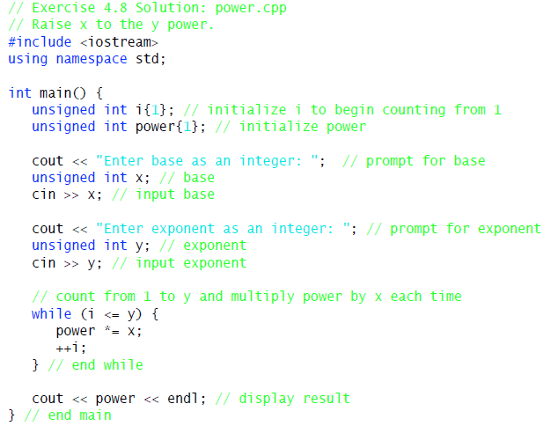

Write a program to compute sum of numbers captured by the user using a while loop and terminated by a letter

// average.cpp

// Computing the average of numbers

#include <iostream>

using namespace std;

int main()

{

int x, count = 0;

float sum = 0.0;

cout << "Please enter some integers:\n"

"(Break with any letter)"

<< endl;

while( cin >> x )

{

sum += x;

++count;

}

cout << "The average of the numbers: "<< sum<< endl;

cout << "The average of the numbers: "

<< sum / count << endl;

return 0;

}

// average.cpp

#include <iostream>

using namespace std;

int main()

{

int age;

string firstname;

string country_code;

cout<<"Enter you age"<< endl;

cin>>age;

while (age>=18){

int counter=1;

while (counter<3){

cout<<"Enter your firstname"<< endl;

cin>>firstname;

cout<<"In which country where you born?"<< endl;

cin>>country_code;

cout<<country_code<<endl;

if (country_code=="ZA" || country_code=="za") {

cout<<"You are eligible to vote"<< endl;

}

else{

cout<<"You are NOT eligible to vote"<< endl;

}

break;

}

}

cout<<"You failed authentication- good bye"<< endl;

return 0;

}

For Loop Exercises

/**

**\* C program to print X number pattern**

**\*/**

**#include<iostream>**

**using namespace std;**

**int main()**

**{**

**int i, j, N;**

**cout<<"Enter N: ";**

**cin>>N;**

**// First part of the pattern**

**for(i=1; i<=N; i++)**

**{**

**// Print trailing spaces**

**for(j=1; j<i; j++)**

**{**

**cout<<" ";**

**}**

**cout<< i;**

**// Print central spacces**

**for(j=1; j<=((N - i) * 2 - 1); j++)**

**{**

**cout<<" ";**

**}**

**// Don't print for last row**

**if(i != N)**

**cout<< i;**

**// Moves on to the next row**

**cout<<"\n";**

**}**

**// Second part of the pattern**

**for(i=N-1; i>=1; i--)**

**{**

**// Print trailing spaces**

**for(j=1; j<i; j++)**

**{**

**cout<<" ";**

**}**

**cout<< i;**

**// Print central spaces**

**for(j=1; j<=((N - i ) * 2 - 1); j++)**

**{**

**cout<<" ";**

**}**

**cout<< i;**

**// Move on to the next line**

**cout<<"\n";**

**}**

**return 0;**

**}**

**OUTPUT**

**Enter N: 5**

**1 1**

**2 2**

**3 3**

**4 4**

**5**

**4 4**

**3 3**

**2 2**

1. **1**

/**

* C program to find reverse of a number

*/

#include <iostream>

using namespace std;

int main()

{

int num, reverse = 0;

/* Input a number from user */

cout<<"Enter any number to find reverse: ";

cin>>num;

/* Repeat the loop until value of num== 0 */

while(num != 0)

{

/*

* Increase place value of reverse and

* add last digit to reverse

*/

reverse = (reverse * 10) + (num % 10);

/* Remove last digit from 'num' */

num =num/ 10;

}

cout<<"Reverse number is : "<< reverse<<endl;

return 0;

}

**Enter any number to find reverse: 951**

**Reverse number is : 159**

**Program to print ASCI TABLE**

**// ascii.cpp : To output an ASCII Code Table**

**#include <iostream>**

**#include <iomanip>**

**using namespace std;**

**int main()**

**{**

**int ac = 16;**

**// To begin with ASCII Code 10 without control characters.**

**while(true)**

**{**

**cout << "\nCharacter Decimal Hexadecimal\n\n";**

**int upper;**

**for( upper =ac + 20; ac < upper && ac <= 122; ++ac)**

**cout << " " << (char)ac**

**// as character**

**<< setw(10) << dec << ac**

**<< setw(10) << hex << ac << endl;**

**if( upper >= 256)**

**break;**

**cout <<"\nPress enter key to continue";**

**char answer;**

**cin.get(answer);**

**if( answer == 'q' || answer == 'Q' )**

**break;**

**cin.sync();**

**// Clear input buffer**

**}**

**return 0;**

**}**

**Write a program for the following numerical game:**

The computer stores a random number between 1 and 15 and the player (user) attempts to guess it. The player has a total of three attempts. After each wrong guess, the computer tells the user if the number was too high or too low. If the third attempt is also wrong, the number is output on screen. The player wins if he or she can guess the number within three attempts. The player is allowed to repeat the game as often as he or she wants.

//A numerical game against the computer

#include <cstdlib>

// Prototypes of srand() and rand()

#include <ctime>

// Prototype of time()

#include <iostream>

using namespace std;

int main()

{

int

number, attempt;

char wb = 'r';

// Repeat or finish.

long sec;

//time( &sec);

// Get the time in seconds.

srand((unsigned)sec);

// Seeds the random

// number generator

cout << "\n\n" << " *******A NUMERICAL GAME*******" << endl;

cout << "\n\nRules of the game:" << endl;

while( wb == 'r')

{

cout << "I have a number between 1 and 15 in mind \n"

<< "You have three chances to guess correctly!\n"

<< endl;

number = (rand() % 15) + 1;

bool found = false;

int count = 0;

while( !found

&& count < 3 )

{

cin.sync();

// Clear input buffer

cin.clear();

cout << ++count << ". attempt: ";

cin >> attempt;

if(attempt < number)

cout << "too small!"<< endl;

else if(attempt > number) cout <<"too big!"<< endl;

else

found = true;

}

if( !found)

cout << "\nI won!"

<< " The number in question was: "

<< number << endl;

else

cout << "\nCongratulations! You won!" << endl;

cout << "Repeat —> <r>Finish —> <f>\n";

do

cin.get(wb);

while( wb != 'r' && wb != 'f');

}

return 0;

}